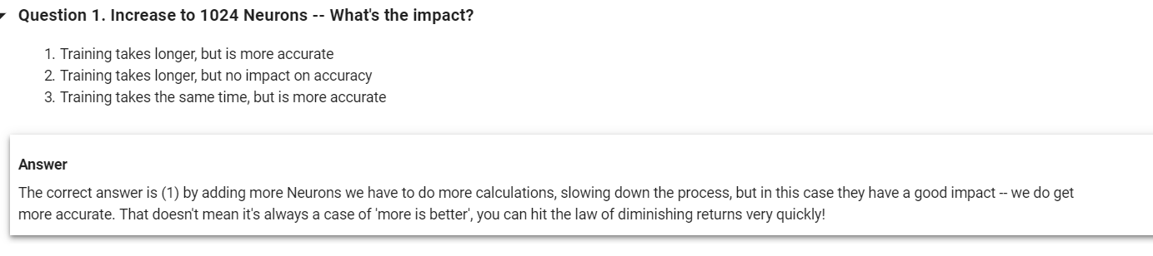

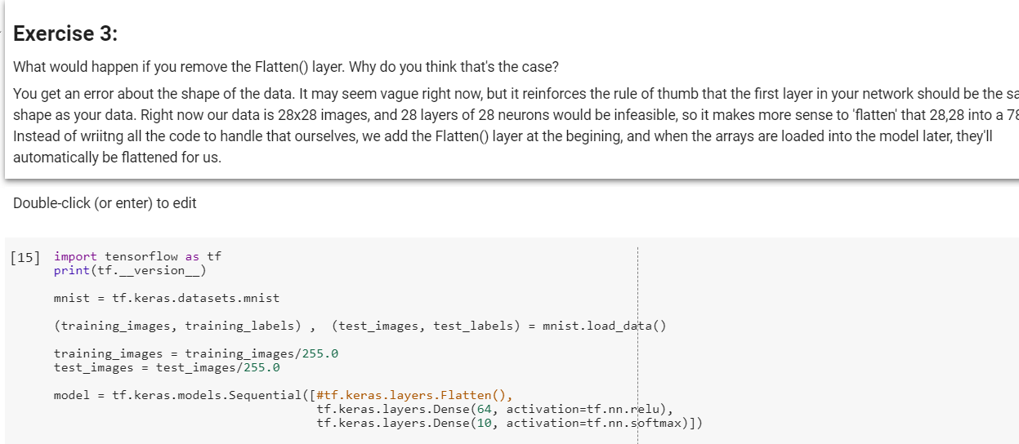

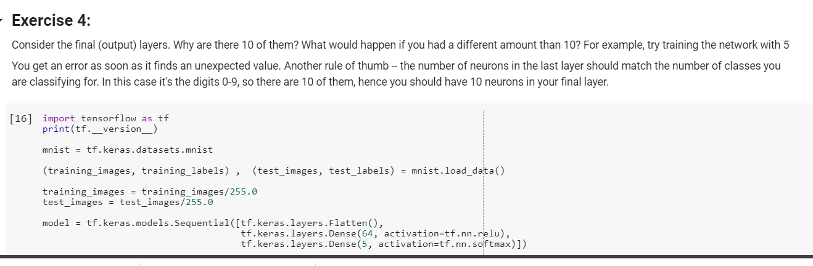

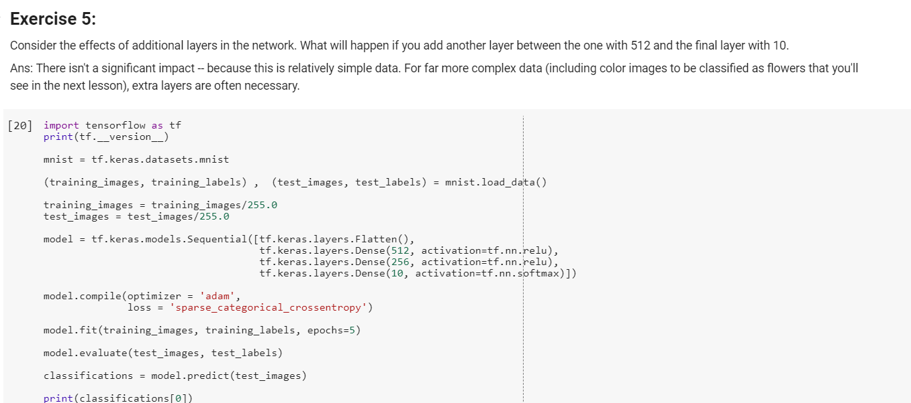

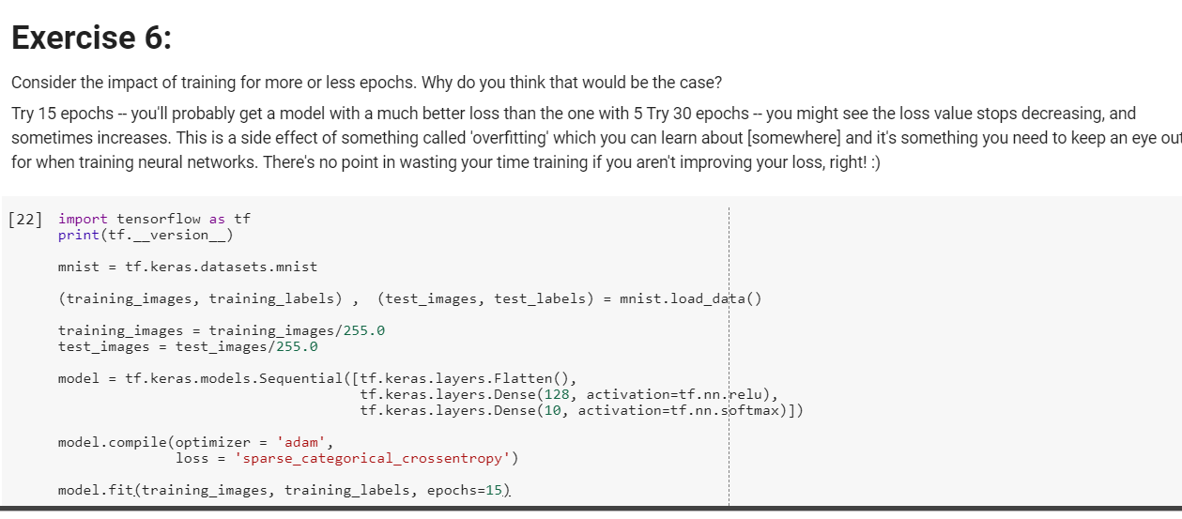

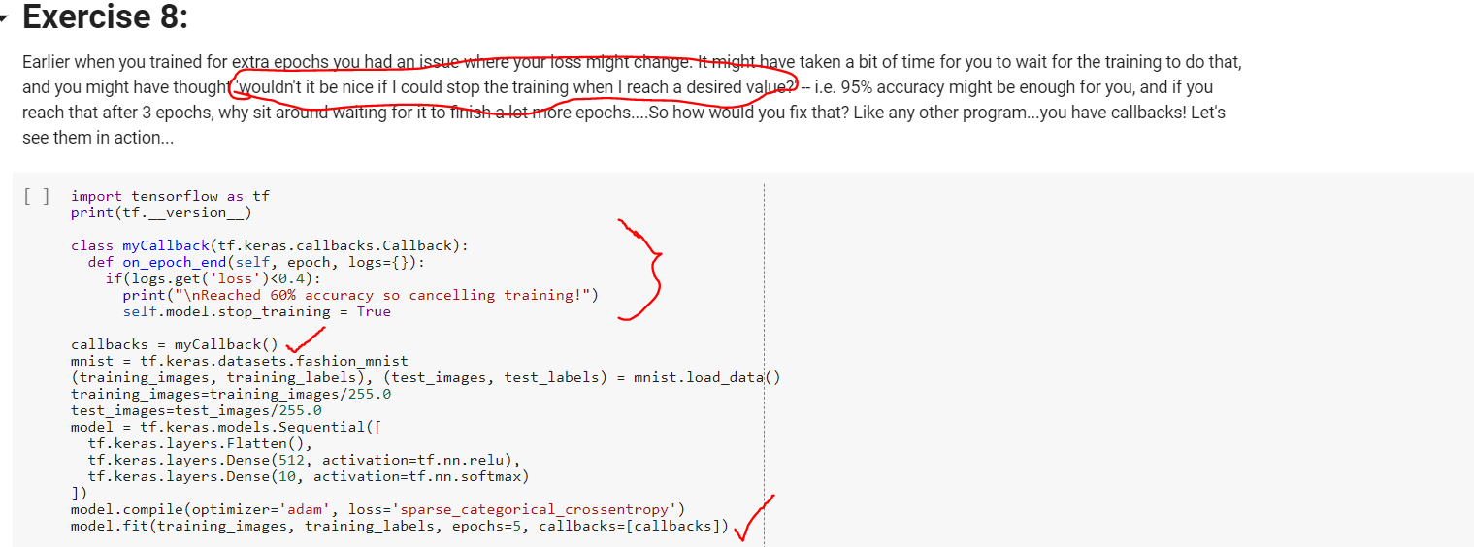

**WEEK3:**

**Now Here till now we checked each pixel and its intensity to tell whether its shoe or bag.**

**Lets say how about instead of pixel we tell its shoe or not by using lace or handbag using handles.**

**This is highly accurate approach than previous approach of individual pixel based.**

**This new approach is called CNN**

**Steps we use**

**1.In image we have lot of waste space.lets use filter to compress image**

**2.Pooling is way to compress image(pooling = go over image with kernel)**

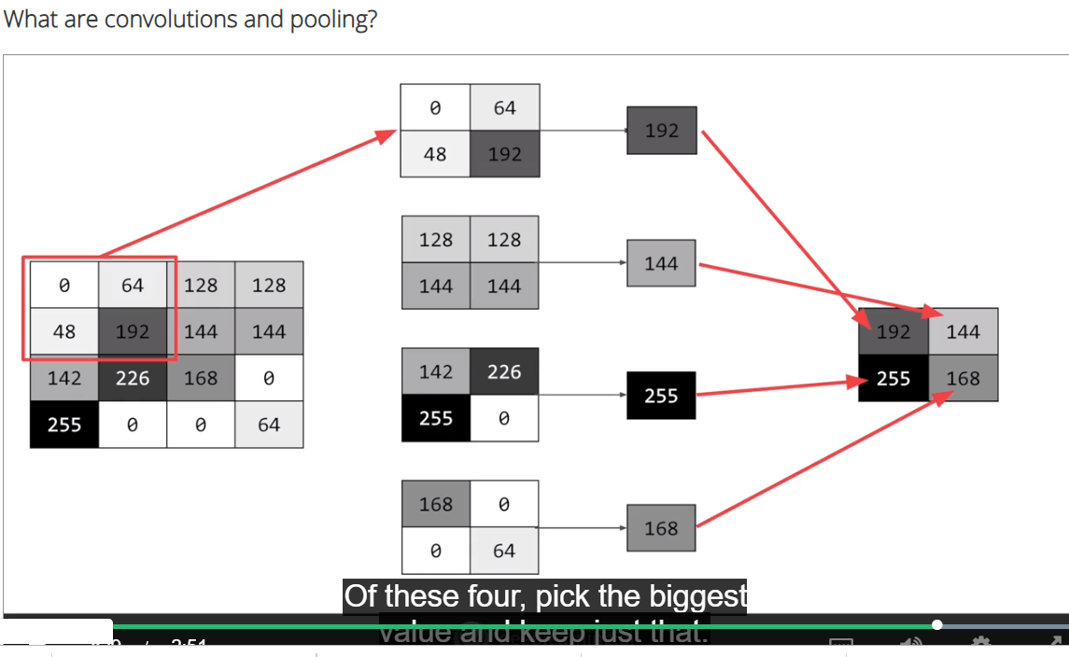

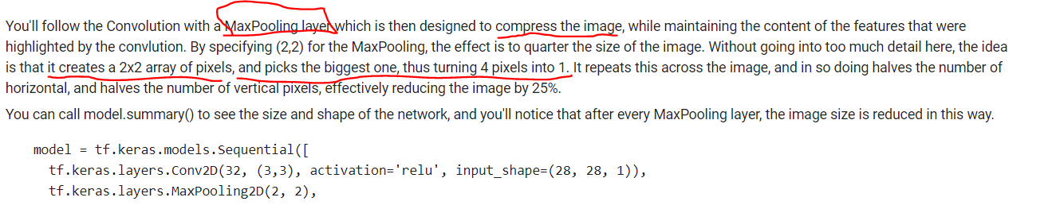

**Note:Before passing directly image pixel in CNN we use convolution on images so that we reduce data and highlight imp features for dense layers**

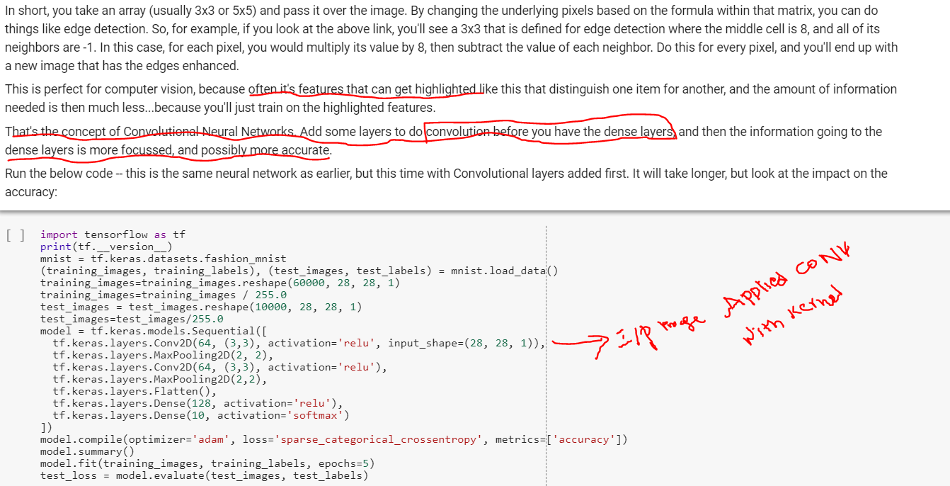

**Image Filters :**

<https://lodev.org/cgtutor/filtering.html>

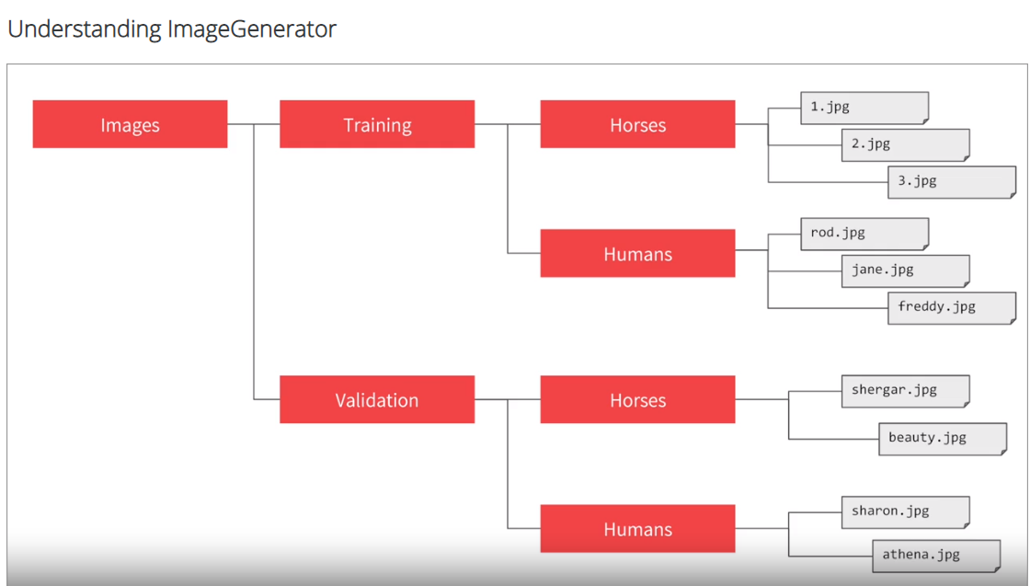

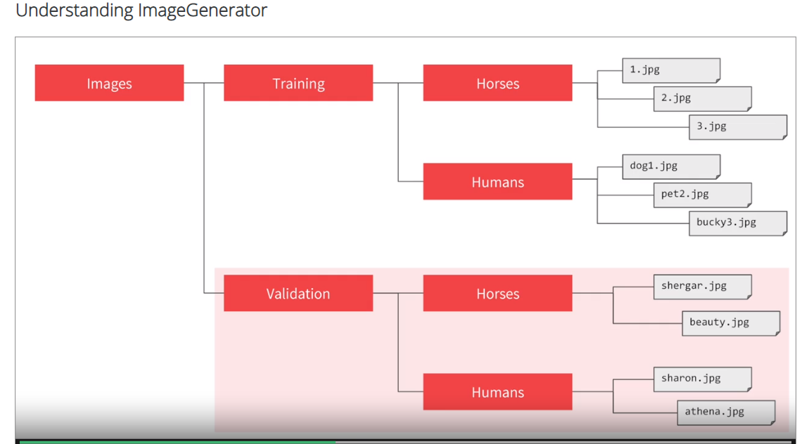

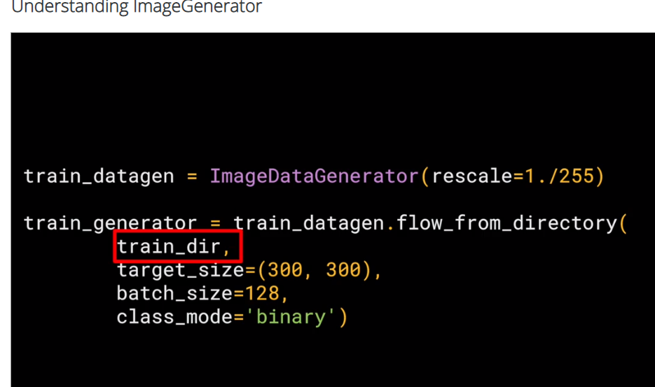

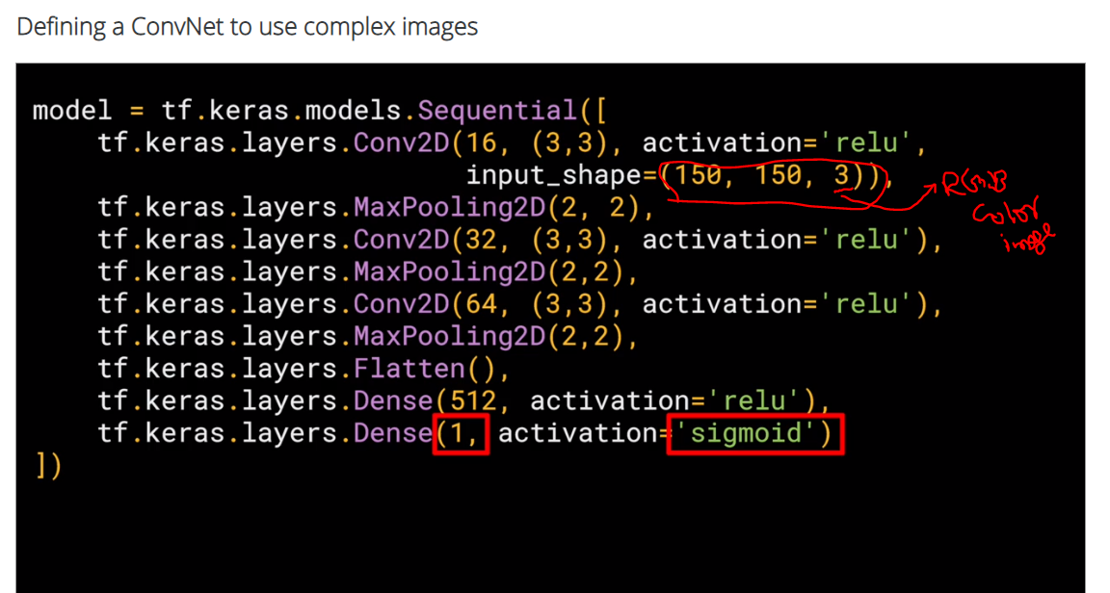

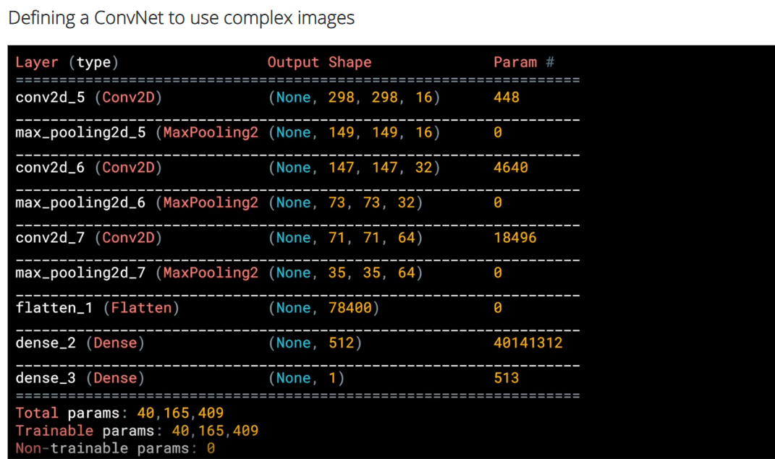

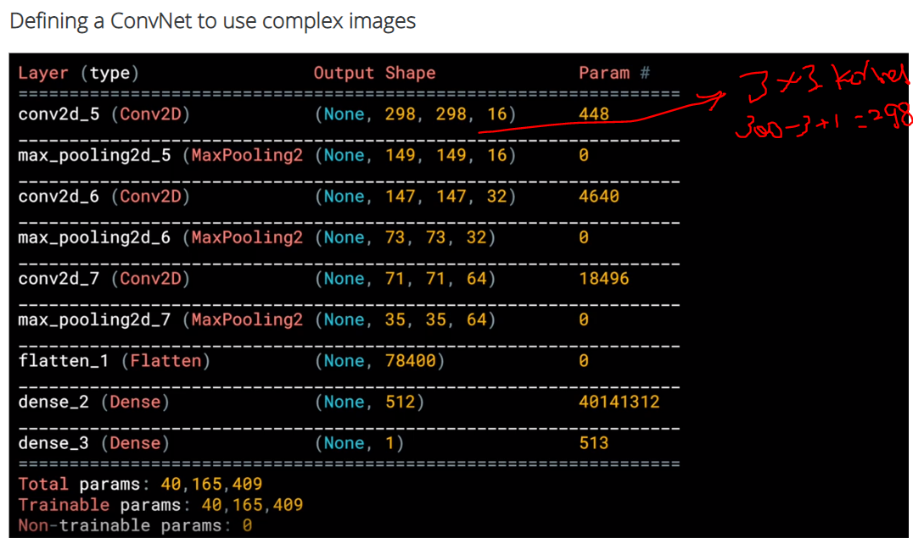

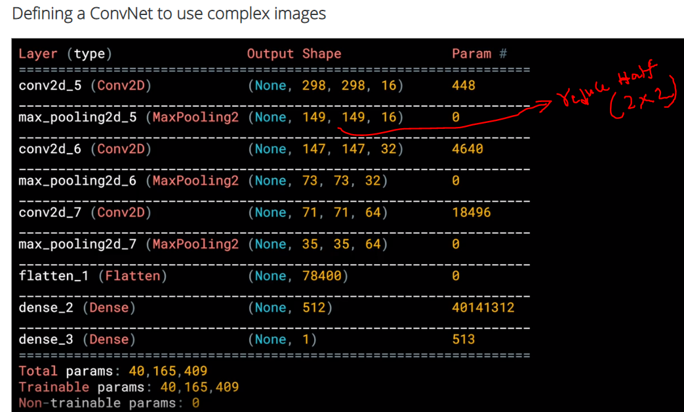

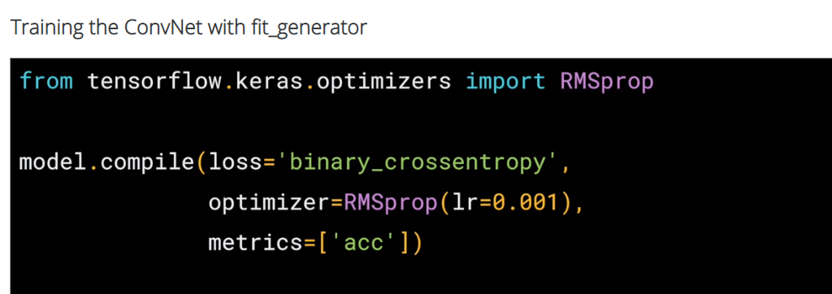

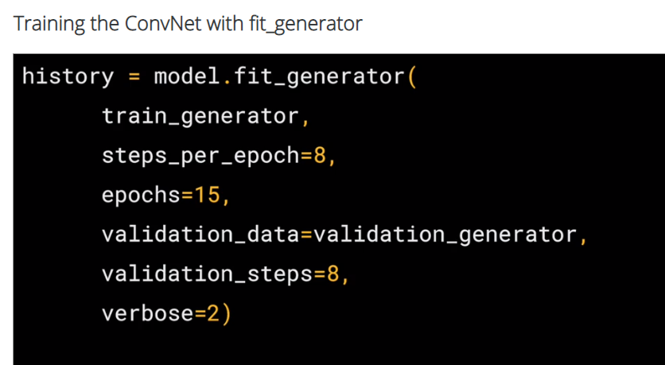

**Train_generator =this streams images from training directory**

**Steps_per epoch= 1024 images in training dir we have so 1024/8 per 1 batch ==total 8 batches**

**Eposchs =same as prev**

**Verbose -n: of msgs to display**

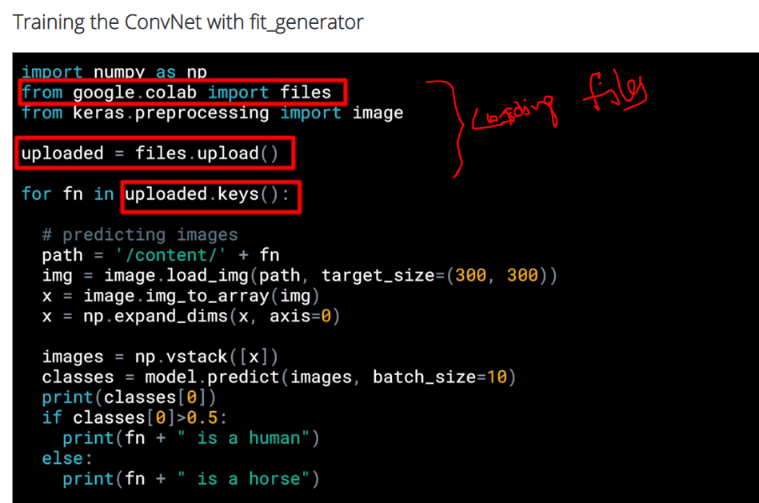

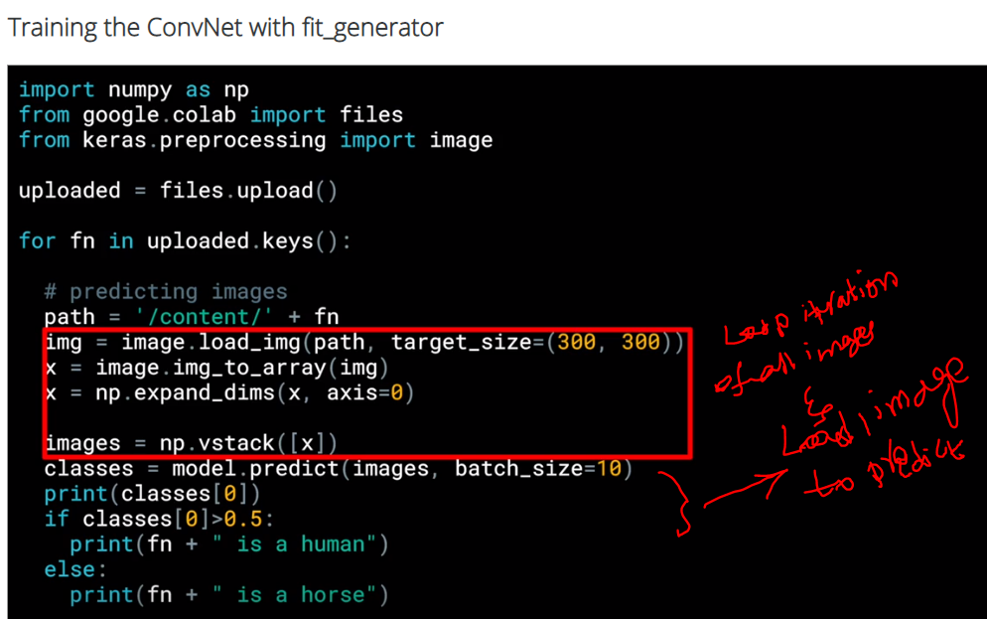

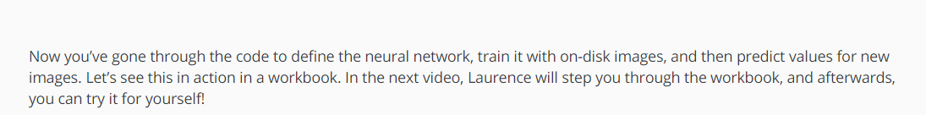

**ImageGenerator:**

**Here we don’t label images(eg: shoe =9 ,bag =6 etc.)**

**Instead what Imagegenerator does is it picks directory name as image label.**

**Eg: we have now 1.horse directory which contain all horse images**

**2.human directory which has all human images.**

**Now when imagegenerator reads images from horse dir it labels as hors and similarly human images**

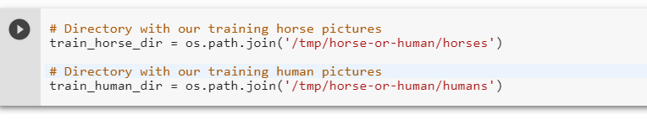

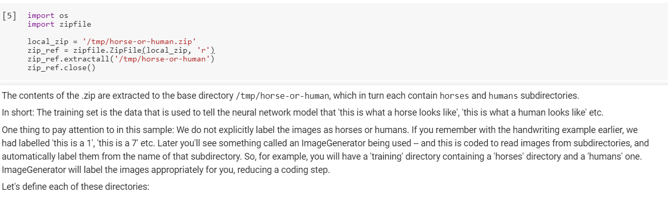

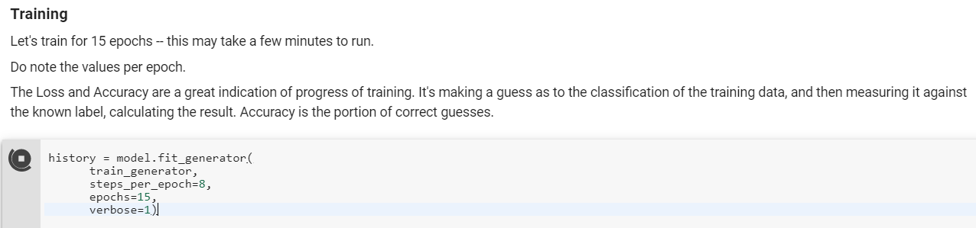

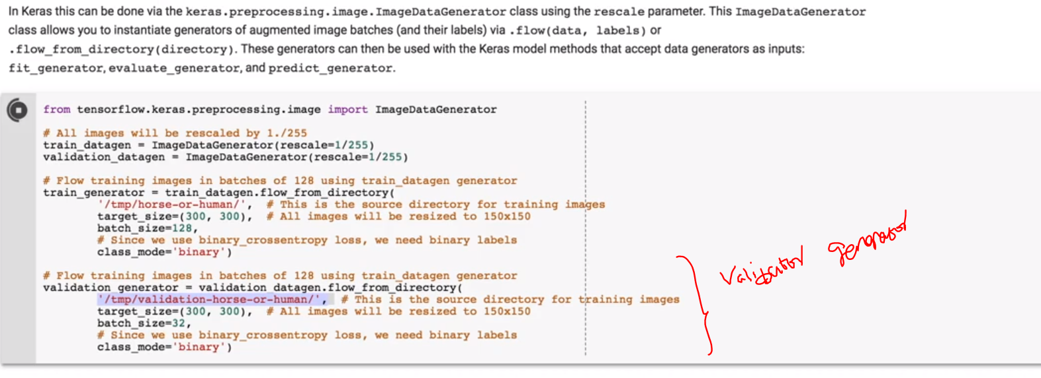

**Validator Genrator:**

**Like training set ,we bring Un seen horse and human data set and keep in folder.**

**Once training is done,we use this validatitng data set to test real accuracy of trained model.**

**Warn:**

**1.False positives or wrong predictions can be observed and we can add those kind of data set in to training data to make model to learn them.**

**2.Validation data set accuracy gives us clear intuition how well model is trained to predict more generically any new data**